**OMIS 652: BUSINESS APPLICATIONS DATABASE MANAGEMENT SYSTEM**

**PROJECT TITLE: LIBRARY MANAGEMENT SYSTEM**

**Group:** G

**Team Members:**

KEERTHANA KAMMARI (Z1849139)

SUMANTH SOMA (Z1857679)

SAI VARUN TANGALLA

ARUN REDDY VALLAPUREDDY

**CONTENTS**

1. INTRODUCTION
2. ENTITIES
3. ENTITY RELATIONSHIP DIAGRAM
4. DATABASE DIAGRAM
5. TABLES
6. QUERIES
7. CONCLUSION
8. REFERENCES
9. **INTRODUCTION**

**PROJECT DELIVERABLE – I**

Project Description – Library4You

Library4You is a library management system located across multiple states in the United States, founded in the year 2000. It improved providing the book(s) service to customers from physical store to retail through multiple ways like physical books and e-books. There are multiple ways a library member can search for a book using Genres, Publishers and Authors. In addition to books, there are magazines, newspapers, media, research topics, journals etc. provided to customers. Library Management also helps to manage the library by keeping a track of books rented and purchased.

Books are supplied by multiple vendors that are maintained in the system, who provide different publications of books or materials. Based on the majority of sales for a particular publisher or author, quantity of requirement for those materials from vendors will increase. A librarian is responsible to maintain the library using the online system

The process of placing an order or availing service from Library4You will start with the customer membership. Customers have the following membership options like gold, platinum or regular membership which is valid for 6 months, 18 months and 90 days respectively. Members can either purchase or rent a book or materials through on-line or from the store. A gold member can take up to 5 books per month on rent, platinum up to 12 books per month and a regular member can avail 3 books per month. Order details will be available to members which also includes tracking details of the shipment. Members can provide rating, review for a particular order placed and also the feedback for the services provided by Library4You.

Library Management system allows the company to maintain information about customers, tracking details, inventory details which will improve the efficiency of the company. It can also gather and procure more quantities of books based on the orders placed and based on the trending topics of market. Library4You requires an effective database system to keep track of all the activities which will scale their operations and satisfy customer needs and services across locations.

1. **ENTITIES:**
2. Store
3. Membership
4. Member
5. FeedBack
6. OrderDetails
7. Order_Rating
8. Rental
9. Purchase
10. Shipment
11. Ebooks
12. Books
13. Suppliers
14. Supplier_Publishers
15. Publishers

**ASSUMPTIONS:**

* Store can give one or many memberships, but membership can be taken in one and only one store.
* Many publishers can be handled by many suppliers and many suppliers can deal many publishers.
* Feedback can be given by one member and member can give many feedbacks.
* Member can take one and only one membership and membership is given to one and only one member.
* Order can have many books/eBooks in it but a book/eBooks can be in one and only one order.
* Feedback is given to one order and order can have many feedbacks.
* Order can have one and only one rental but rental can have different order number at different time.

**PROJECT DELIVERABLE – II**

1. **ENTITY RELATIONSHIP DIAGRAM (ERD)**

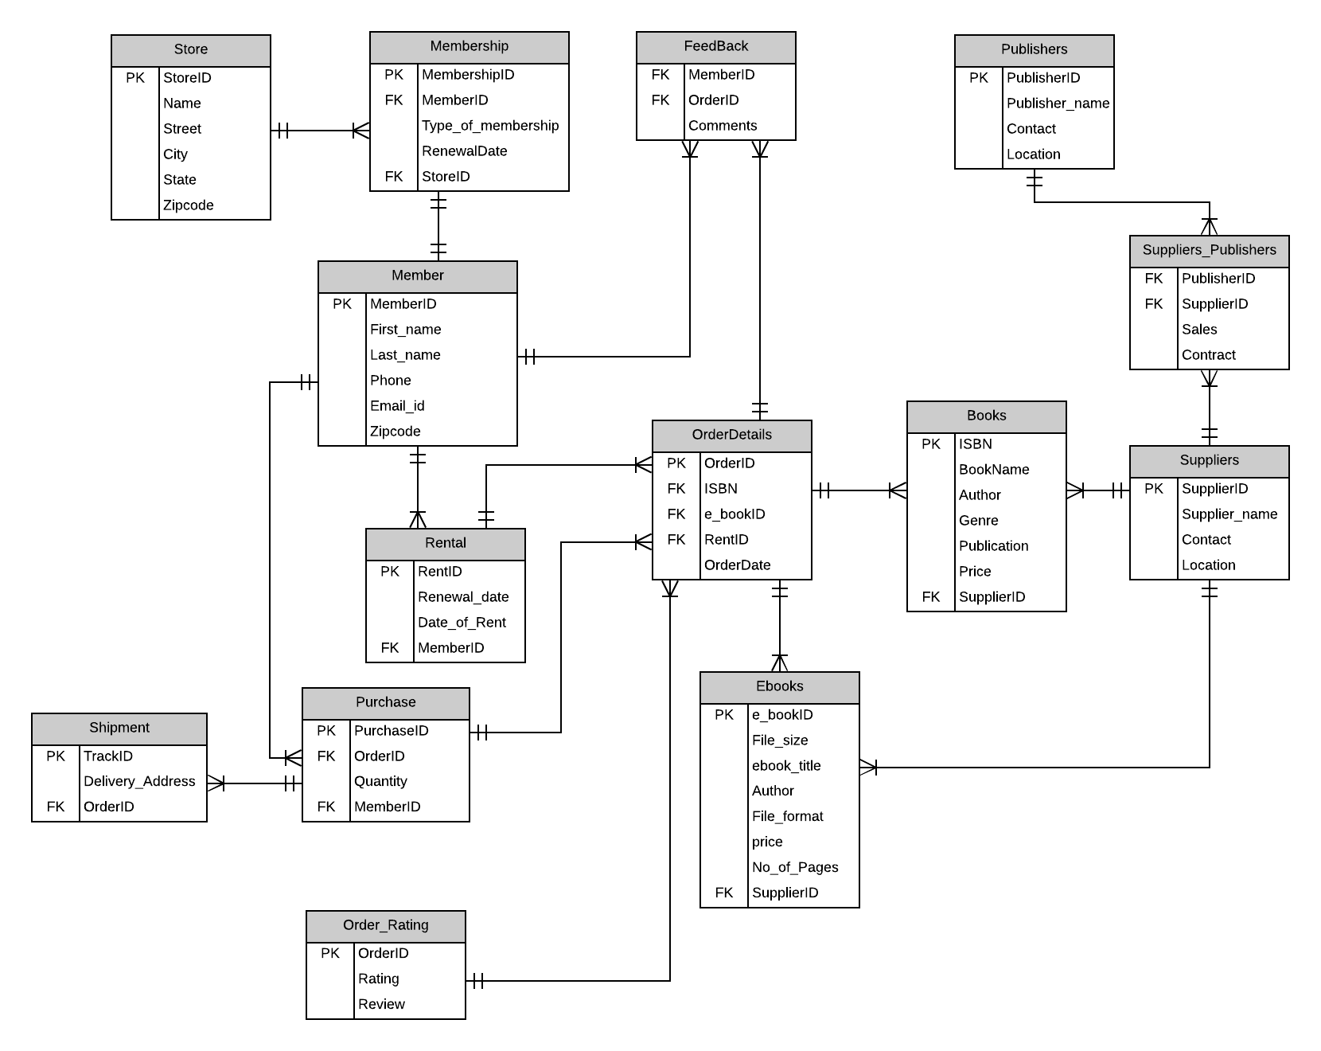

1. **DATABASE DIAGRAM**

Following is the Database diagram mapping captured from SQL Server Management Studio

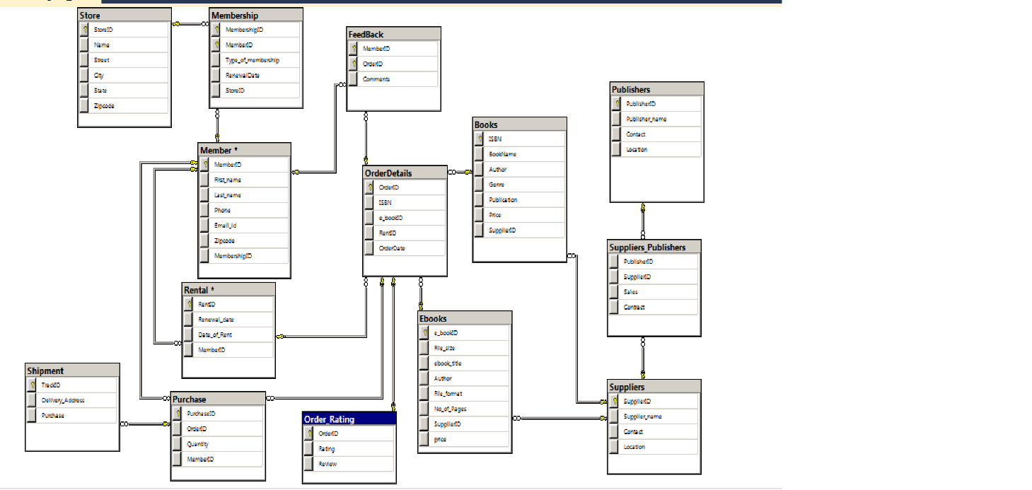

**PROJECT DELIVERABLE – III**

1. **TABLES WITH PRIMARY AND FOREIGN KEYS**

There is a total of 14 entities including bridging entities which are created in SQL server Management Studio and following are the screenshots of tables where PK indicates Primary Key and FK indicates Foreign Keys

1. Books and Ebooks Entities
   1. Books
      1. ISBN – PK
      2. SupplierID – FK
   2. Ebooks
      1. e_bookID – PK
      2. SupplierID – FK

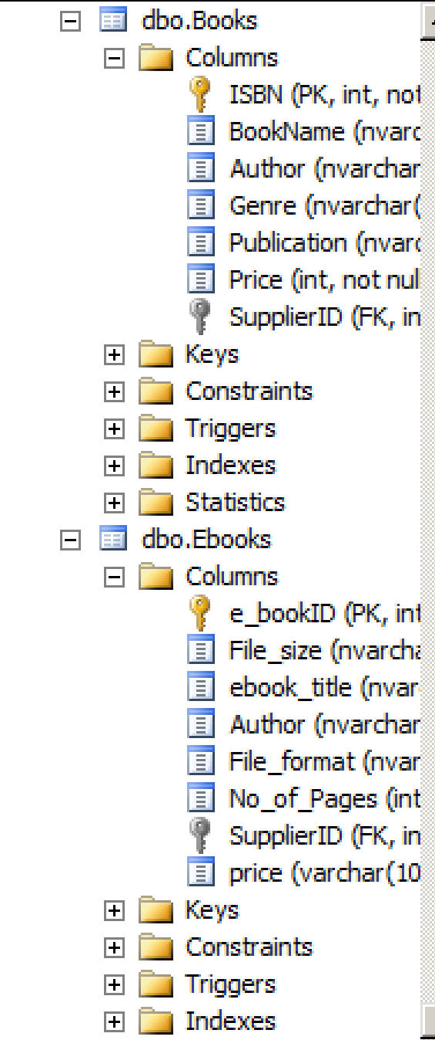

1. FeedBack and Member Entities

3) Feedback

1. MemberID – PK
2. OrderID – PK

4) Member

1. MemberID - PK

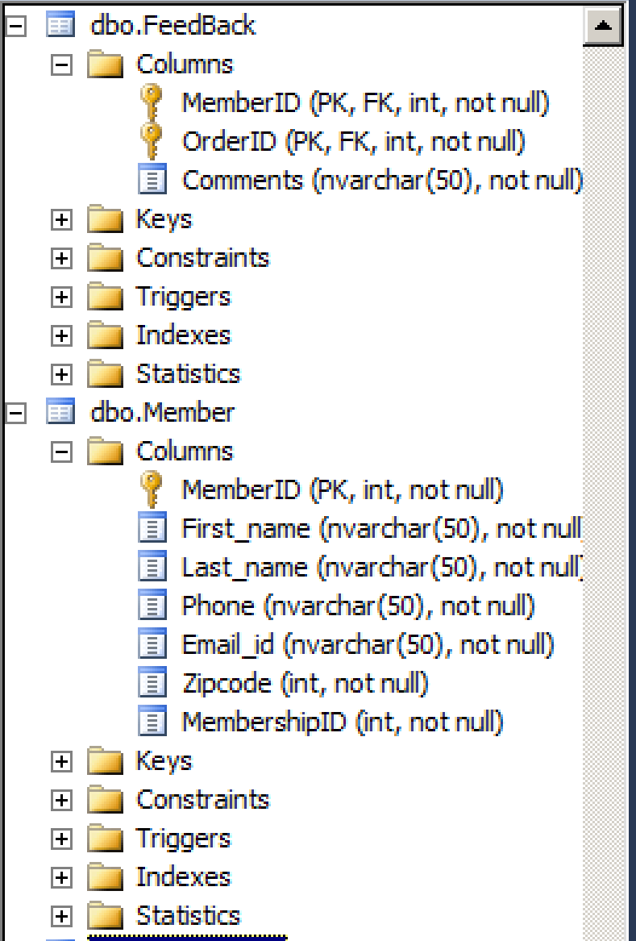

1. Membership and Order Rating Entities

5) Membership – Below two primary keys form a composite key

1. MembershipID – PK
2. MemberID – PK
3. StoreID – FK

6) Order_Rating

1. OrderID - PK

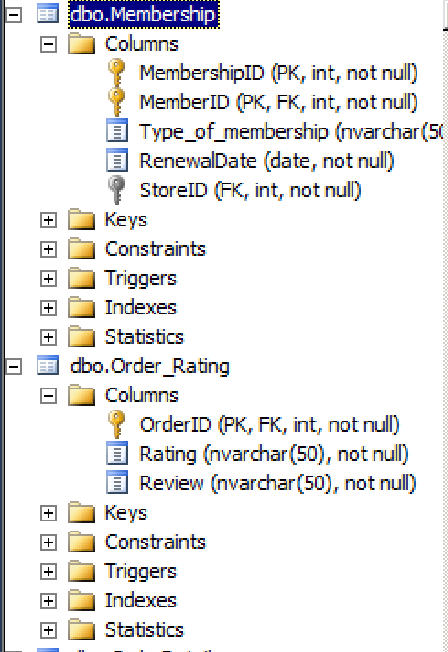

1. Order Details and Publishers Entities

7) OrderDetails

1. OrderID – PK
2. ISBN – FK
3. e_bookID – FK
4. RentID – FK

8) Publishers

1. PublisherID - PK

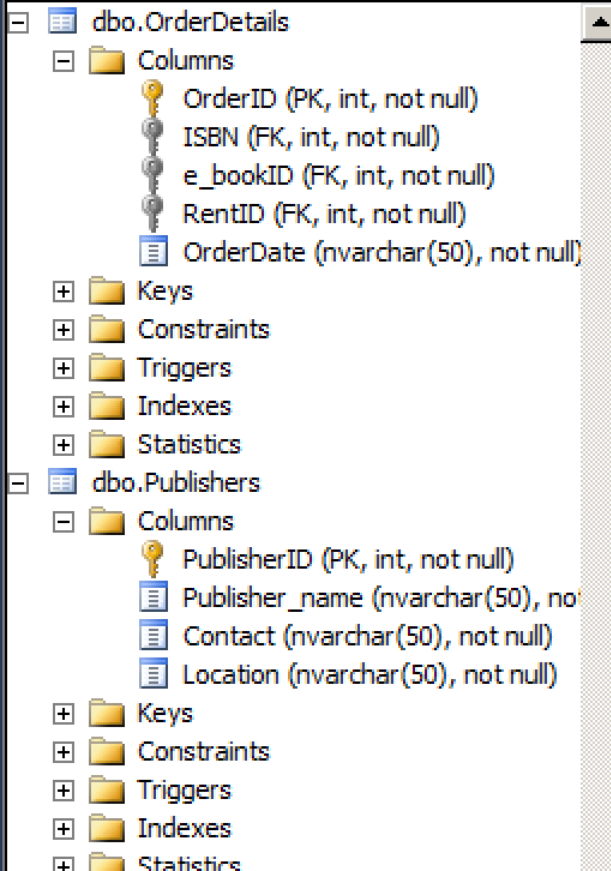

1. Purchase and Rental Entities

9) Purchase

1. PurchaseID – PK
2. OrderID – FK
3. MemberID – FK

10) Rental

1. RentID – PK
2. MemberID - FK

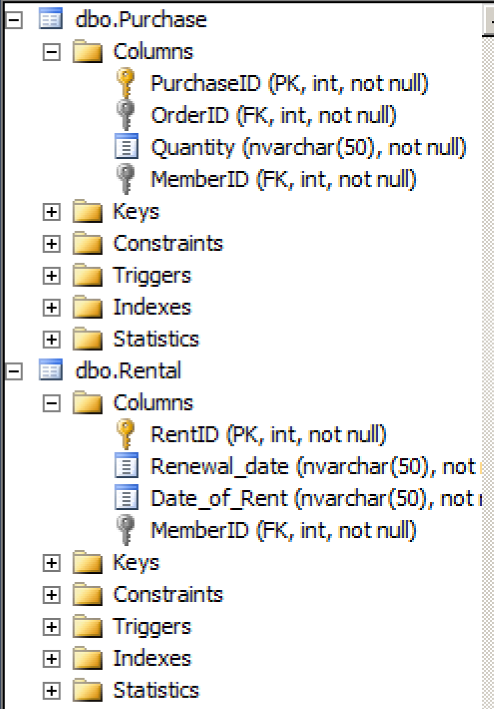

1. Shipment and Store Entities

11) Shipment

1. TrackID – PK
2. PurchaseID – FK

12) Store

1. StoreID - PK

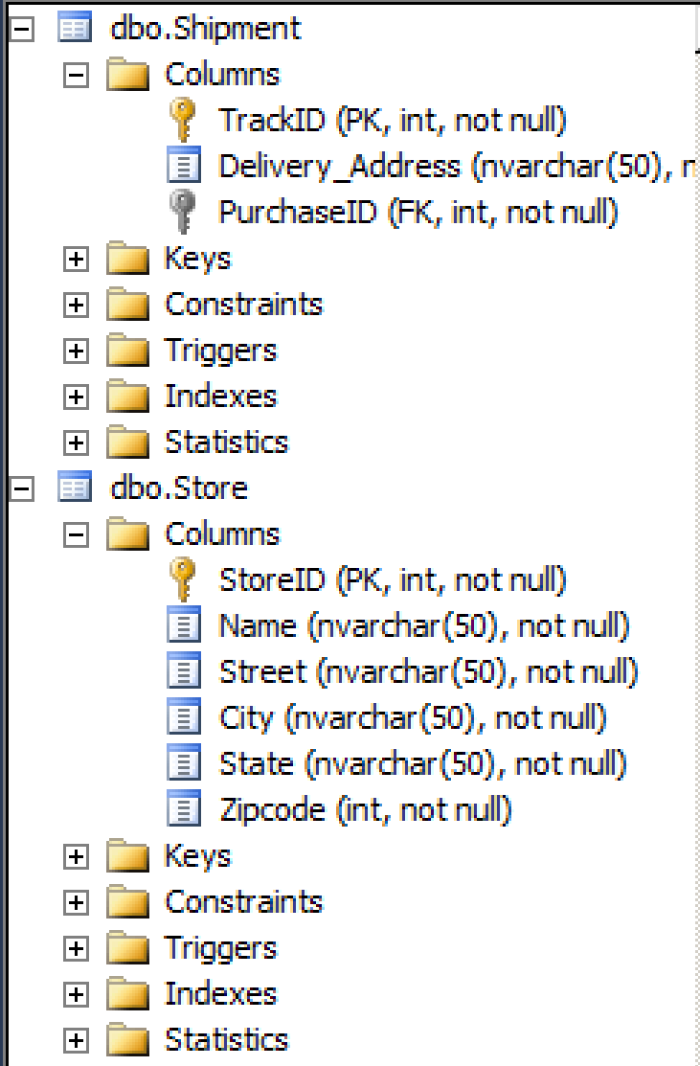

1. Suppliers and Suppliers_Publishers (Bridging entity) Entity
2. Suppliers
   1. SupplierID – PK
3. Suppliers_Publishers
   1. PublisherID – FK
   2. SupplierID - FK

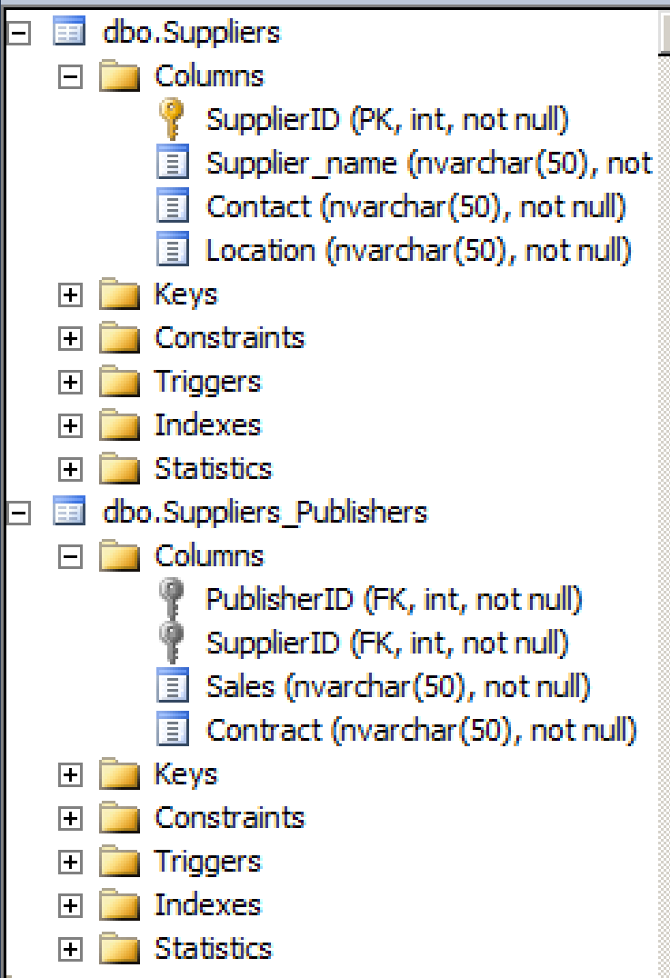

1. **20 QUERIES:**